
Otsuka’s 4Q/FY2025 Earnings; Inqovi PDUFA delayed until May 25, 2026; ASTX030 submission plans in 2028

Company: Otsuka  Drug: Inqovi/Inaqovi (ASTX727, cedazuridine + decitabine; HMA); ASTX030 (cedazuridine + azacitidine; HMA) | Date: Feb 13, 2026  Source(s): Financial results, Factbook, Presentation, Webcast, Transcript
What happened:
- Otsuka published its 4Q/FY2025 earnings results and announced that the PDUFA date for Ven + Inqovi in 1L unfit AML has been delayed to May 25, 2026 (updated guidance, previously Feb 25, 2026)
- Otsuka announced regulatory submission for ASTX030 based on Ph 2/3 AZTOUND (1L unfit AML, Ven + Inqovi, N=236) study in 2028 (updated guidance, previously 2027)

Key Approval Timelines:
 | US | EU
1L unfit AML  (Ph 1/2 ASCERTAIN-V;  Ven +Inqovi) | PDUFA: May 25, 2026 (updated guidance, previously Feb 25, 2026) | 2Q 2026  (Type II variation + 6 mo)  (CI assumptions based on potential positive opinion in Feb 2026, + ~67 days for EU approval; no changes to timelines)
1L unfit AML  (Planned Ph 3 study;  Ven + ASTX030) | 2Q 2030  (NDA + 8 mo)  (Assuming an aggressive initiation of a registrational study in 3Q 2027, post-study PCD (May 2027), leading to a potential submission in 3Q 2029; new guidance, base scenario) | 1Q 2031  (MAA + 14 mo)  (Assuming an aggressive initiation of a registrational study in 3Q 2027, post-study PCD (May 2027), leading to a potential submission in 3Q 2029; new guidance, base scenario)
1L unfit AML  (Ph 3 ASTX030-01; ASTX030 monotherapy) | NA | 1Q 2029  (MAA + 14 mo)  (CI assumptions based on Nov 2027 PCD and submission in 4Q 2027; no changes to timelines)

Impact (CI PoV): HIGH
- Ven + Inqovi: The PDUFA delay and continued EU regulatory processing for Ven + Inqovi suggest a longer path to label expansion, potentially tempering near-term momentum; Notably Ven + In(a)qovi was also absent from CHMP commentary in Jan 2025. Company did not provide clarity on the reason for PDUFA delay.
- Ven + ASTX030: While an aggressive scenario could envision US AA of Ven + ASTX030 in 1L unfit AML by 2Q 2029, based on the Ph 1 arm of the Ph 2/3 AZTOUND study, this appears unlikely. A more credible scenario suggests a longer-term impact to Ven, with a potential second approval of all-oral Ven + ASTX030 in 2Q 2030.

Why it matters:
In(a)qovi (ASTX727)
- No explanation was provided for the PDUFA’s delay to May 25, 2026 (updated guidance, previously Feb 25, 2026)
- The updated PDUFA timeline for Ven + Inqovi in the US and the absence of an opinion in the Jan 2026 CHMP outcomes reflect extended regulatory review timelines across regions; the underlying drivers have not been publicly disclosed and may relate to routine review processes such as labelling, manufacturing, etc. or clinical considerations
  - The mOS difference observed is marginal between VIALE-A vs. ASCERTAIN-V (mOS: 14.7 months vs. 15.5 months), however, Ven + Inqovi provides an all-oral convenience option
ASTX030
- In the Otsuka 4Q/FY2025 earnings presentation, the US filing of ASTX030 in AML in 2028 is based on a Ph 3 study
- Ph 3 EU study (ASTX030-01, PCD: Nov 2027) may support a future EU approval for ASTX030; however, it remains unclear whether this study could be leveraged for a US label in 1L unfit AML. CI will continue to monitor ongoing clinical development and any updates on US regulatory strategy or market entry timelines.

Tell me more:
Financial Highlights
- The projected revenue for FY2026 is ¥2,520 B ($16.6 B) (1 USD = 150 Yen)

Sales | Overall | In(a)qovi
FY2025 (¥ B ($ M)) | ¥2,468.9 B (16.51 Bª) | ¥20.9 B (139.69 Mª)
FY2024 (¥ B ($ M)) | ¥2,329.9 B ($15.36 B^{b}) | ¥16.9 B ($111.46 M^{b})
YoY change | +6% | +23.7%
4Q 2025 (¥ B ($ M)) | ¥650.1 B ($4.35 Bª) | ¥5.9 B ($39.44 Mª)
4Q 2024 (¥ B ($ M)) | ¥599.8 B ($3.95 M^{b}) | ¥4.7 B ($30.99 M^{b})
3Q 2025 (¥ B ($ M)) | ¥638 B ($4.27 Bª) | ¥6 B ($40.11 Mª)
YoY change | +8.4% | +25.5%
QoQ change | +1.9% | -1.67%

ªConversion factor: 1 USD = 149.61 Yen for FY2025
^{b}Conversion factor: 1 USD = 151.68 Yen for FY2024

Data Tables
- Data summary from ASCO 2025 and EHA 2025
Trial | Registrational Ph 1/2 ASCERTAIN-V
Treatment | Ven + ASTX727
Data Ref. | ASCO 2025, EHA 2025
Population (LOT) | 1L unfit AML
Efficacy (n) | 101
mFU (months) | 11.2
CR (%) | 46.5
CRi (%) | 16.8
CRh (%) | 5
CR/CRi (%) | 63.4
CR/CRh (%) | 51.5
mToCR (months) | 2.4
mDoCR (months) | NR
mOS (months) | 15.5
Gr≥3 AEs (%) | 98
Most common Gr≥3 TEAEs (%) | Febrile neutropenia (50), anemia (39), neutropenia (36)

Relevant Slides: Otsuka 4Q 2025 Earnings Presentation

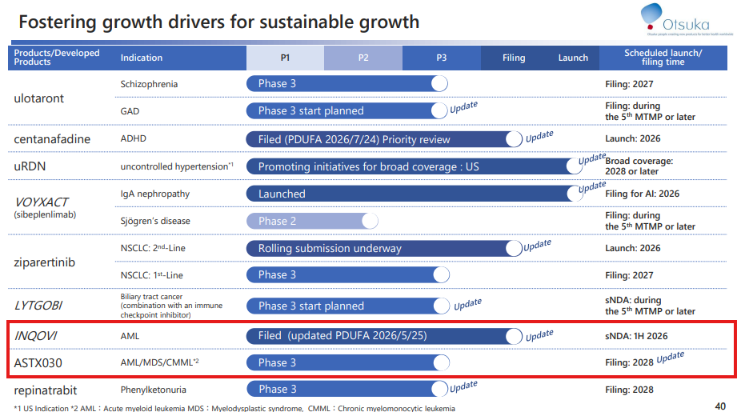

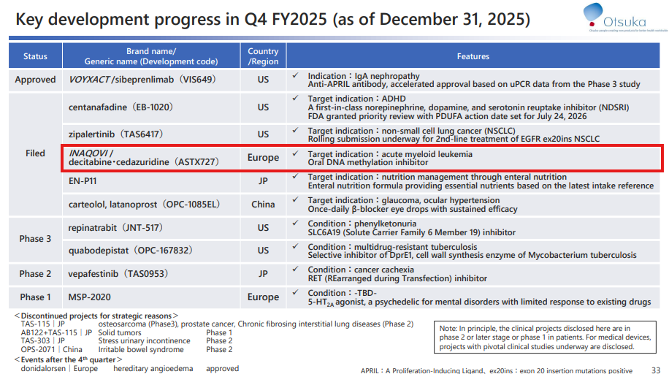

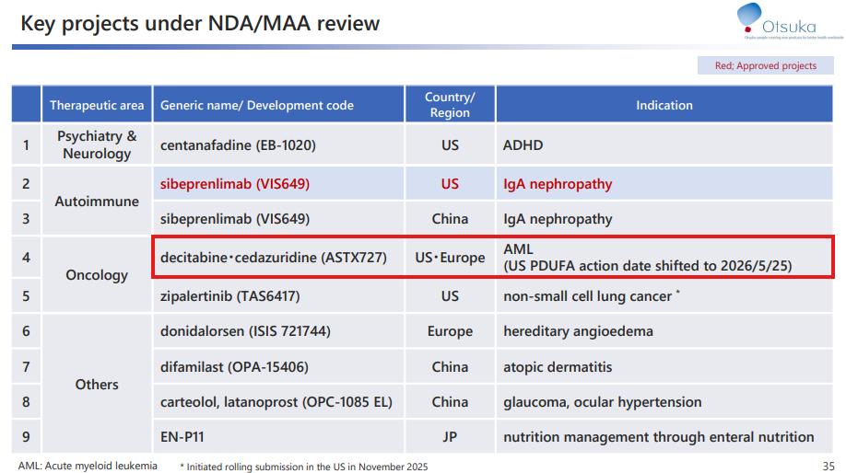

For questions, please reach out to:
International / Affiliates: Harjit Bajwa
US: Richa Sharma

Invite your colleagues to CI Edge | Manage Email Preferences | Unsubscribe

This document/email contains competitive intelligence collected via an approved competitive intelligence supplier working on behalf of AbbVie. We collect competitive intelligence consistent with industry standards and AbbVie policy. Not for field distribution. Please reach out to APEX/IMABI, Legal, or OEC teams with any questions.

